# Vgnezdene zanke

## Naloga 1

#include <iostream>  
using namespace std;  
int main() {  
  
 int x;  
  
 cout << "Podaj neko cifro";  
 cin >> x;  
  
 for (int i = 0; i < x; ++i) {  
 for (int j = 0; j < x; ++j) {  
 if (j == 0 || j == x - 1 || i == 0 || i == x - 1) {  
 cout << "1 ";  
 }else {  
 cout << "0 ";  
 }  
 }  
 cout << endl;  
 }  
  
 return 0;  
}

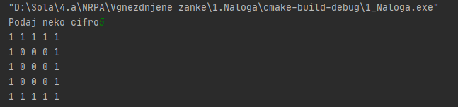

## Naloga 2

#include <iostream>  
using namespace std;  
int main() {  
  
 int x;  
  
 cout << "Podaj neko cifro";  
 cin >> x;  
  
 for (int i = 0; i < x; ++i) {  
 for (int j = 0; j < x; ++j) {  
 if (j == 0 || j == x - 1 || i == 0 || i == x - 1) {  
 cout << i + 1 << " ";  
 }else {  
 cout << "0 ";  
 }  
 }  
 cout << endl;  
 }  
  
 return 0;  
}

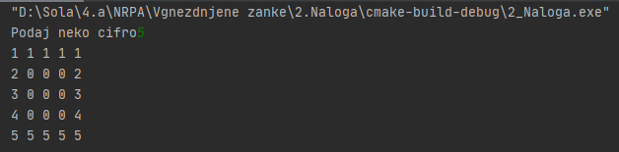

## Naloga 3

#include <iostream>  
using namespace std;  
int main() {  
  
 int x;  
  
 cout << "Podaj liho cifro";  
 cin >> x;  
  
 if (x % 2 == 0){  
 cout << "Vpisi liho cifro!!";  
 return 0;  
 }  
  
  
 for (int i = 0; i < x; ++i) {  
 for (int j = 0; j < x; ++j) {  
 if (i == x / 2 || j == x / 2) {  
 cout << "1 ";  
 }else {  
 cout << "0 ";  
 }  
 }  
 cout << endl;  
 }  
  
 return 0;  
}

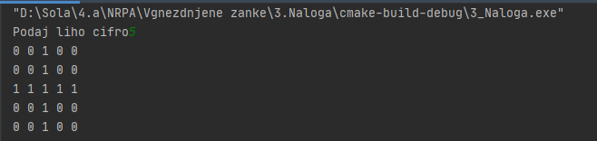

## Naloga 4

#include <iostream>  
using namespace std;  
int main() {  
  
 int x;  
  
 cout << "Podaj liho cifro";  
 cin >> x;  
  
 if (x % 2 == 0){  
 cout << "Vpisi liho cifro!!";  
 return 0;  
 }  
  
  
 for (int i = 0; i < x; ++i) {  
 for (int j = 0; j < x; ++j) {  
 if (i == x / 2 || j == x / 2) {  
 cout << i + 1 << " ";  
 }else {  
 cout << "0 ";  
 }  
 }  
 cout << endl;  
 }  
  
 return 0;  
}

